**Правительство Российской Федерации**

**Федеральное государственное автономное образовательное учреждение высшего профессионального образования**

**Национальный исследовательский университет    
"Высшая школа экономики"**

**Факультет  компьютерных наук**

**магистерская работа**

**Программа для оценки оптического потока на основе подходов глубокого обучения**

Студент:

**Джозеф Африйие Аттакорах**

Научный руководитель:

**Салех Хади Мухаммед, доцент**

Москва, 2020 г.

**Government of the Russian Federation**

**National Research University Higher School of Economics**

**Faculty of computer science**

**Master Thesis**

**An Application for Optical Flow Estimation Based on Deep Learning Approaches**

Written by:

**Joseph Afriyie Attakorah**

Supervisor:

**Professor Hadi Saleh**

​Moscow, 2020

Table of Contents

INTRODUCTION 4

BACKGROUND 5

OPTICAL FLOW ESTIMATION 6

STATE OF THE ART (LITERATURE REVIEW) 8

Methods for Determination 8

TECHNOLOGIES 9

APPROACH 9

REFERENCES 10

# INTRODUCTION

Images are great in all; videos are even cooler because we have more information in a video than in an image. Because in an image we have just the spatial positioning of the pixels, thus where they are in the image relative to each other. A video consists of a set of individual film frames or video frames, which are typically many still images, that sequentially compose the complete moving picture to make up the video over time. So in a video, we get the same spatial information but also have an additional temporal component. Meaning we do not have only the location of a pixel spatially but also when this pixel exists. This additional information gives knowledge about the time and duration of the pixel. In other words, information in a video is encoded not only spatially, but also sequentially and according to a specific order. This amount of information opens a lot of doors on what we can look into and makes classifying videos more interesting. Optical flow is one of these doors. Optical flow is computer vision technique use to track the apparent motion of objects in a video. This technique has a number of different applications including video compression, video stabilization, video description (a more recent application area), object detection and tracking (e.g. detect and track vehicles in an automated traffic surveillance application), velocity estimation, and to mention but a few.

Optical flow is the pattern of apparent motion of objects, surfaces, and edges in a visual scene caused by the relative motion between an observer and a scene[9]. Optical flow can also be defined as the distribution of apparent velocities of movement of brightness pattern in an image [10]. Optical flow is a per-pixel prediction which means to estimate how the pixel brightness moves across the screen over time [11].

With the recent advancements in AI, Deep nets are becoming a popular approach to solving problems. In this project, we try to achieve an algorithm that prioritizes motion as a key characteristic of classification and is computationally feasible within the real-world context. The best possible way is through optical flow

Deep learning is part of a broader family of machine learning methods based on artificial neural networks that uses multiple layers to progressively extract higher level features from the raw input. For example, in image processing, lower layers may identify edges, while higher layers may identify the concepts relevant to a human such as digits or letters or faces. Learning can be supervised, semi-supervised or unsupervised

# BACKGROUND

The concept of optical flow was introduced by the American psychologist James J. Gibson in the 1940s to describe the visual stimulus provided to animals moving through the world. Gibson stressed the importance of optic flow for affordance perception, the ability to discern possibilities for action within the environment [12].

We live in a moving world. Perceiving, understanding and predicting motion is an important part of our daily lives.

As a goal to determine how computers can be made to gain high-level understanding from digital images and videos and to automate tasks that the human visual system can do, optical flow became a computer vision technique with pioneering researchers Horn and Schunck.

Now we cannot talk about optical flow without mentioning motion. Motion estimation is a relevant task of video analysis. It can be used to find the motion fields, to identify moving objects, calculate object path or trajectory and to find their speed. However, many of the methods developed for the motion analysis are computationally expensive or require already segmented picture.

In this paper, we present an efficient method for computing direction of motion of a vehicle and estimate its speed. The proposed method firstly uses optical flow algorithm to calculate changes in the intensity of the pixels of the images. These apparent velocity components are then subjected to image processing techniques to obtain centroid of the vehicle across the frames. The image coordinates of the centroid are mapped to World space. Using this information the velocity of the vehicle is estimated. In the following sections, we briefly survey the relevant literature, describe our method and study the experiments performed

Optical-flow methods are based on computing estimates of the motion of the image intensities over time in a video. The flow fields can then be analyzed to produce segmentations into regions, which might be associated with moving objects [13]. Optical-flow or motion-estimation algorithms can be used to detect and delineate independently moving objects, even in the presence of camera motion. Of course, optical-flow-based techniques are computationally complex, and hence require fast hardware and software solutions to implement. Since optical flow is fundamentally a differential quantity, estimation of it is highly susceptible to noise; ameliorating the noise sensitivity can imply increases in complexity [13]

There are quite a few deep learning algorithms that are applied to the spatial domain ranging from classification, segmentation, scene understanding etc. However, algorithms that perform well in the temporal domain are fewer and less developed than their spatial counterpart. This is because of the complicated nature of adding time to the equation. Optical flow is a desired computer vision technique that prioritizes motion as a key characteristic of classification and is computationally feasible in the real world context.

# OPTICAL FLOW ESTIMATION

In a typical scene like one below we might want to estimate the motion of the vehicles and track their direction as well as their speed.



Sequences of ordered images allow the estimation of motion as either instantaneous image velocities or discrete image displacements. The optical flow methods try to calculate the motion between two image frames which are taken at times **t** and **t + Δt** at every voxel position

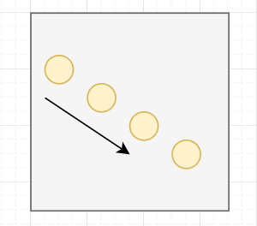 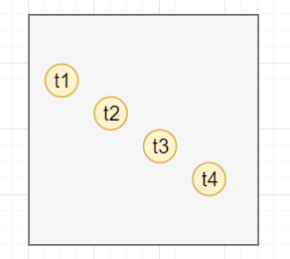

To make an Intuition behind optical flow, lets consider the above diagram to depict an object, say a ball, thrown from the upper left corner of the scene to the lower right corner of the scene. The t1…t4 represent the balls position at specific times, sequentially.

If we want to track an object through a video, in a computer level, we only have access to the raw pixels. We take individual frames look at the pixels and track them in successive frames as depicted below in the diagram.

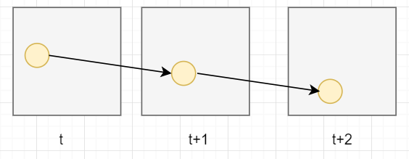

We maintain the assumption that the observed brightness of any object point is constant over time. Implying that nearby points in the image plane move in a similar manner or move together, and pixel intensities don’t rapidly change between consecutive frames thus pixel values in two successive frames don’t immediately change.

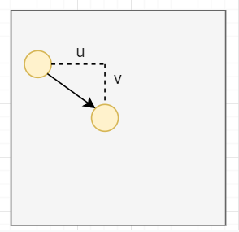

So the problem of flow here is that the pixel moved in the x direction by some amount **u** and down in the y direction by some amount **v**. So the challenge of flow is to find the **u** and **v**  that it moved, which is equal to the displacement depicted by the arrow. With that we can track the path. This is what optical flow seeks to solve.

The mathematics involved has been handled by pioneering researchers, but their solutions are computationally expensive.

From that time, the problem of optical flow has historically been an optimization problem in computer vision. Since optical flow is used in motion detection, video compression and several safety-critical applications like self-driving cars, it is important to optimize it to the best of its performance with state-of-the-art.

The application of deep learning techniques in recent times has shown impressive results. Compared with traditional methods, CNN achieved a large improvement in quality in estimating optical flow.

# STATE OF THE ART (LITERATURE REVIEW)

After the American psychologist James J. Gibson in the 1940s introduced the concept of optical flow, followers and other researchers further developed on this concept and eventually this concept was established as a computer vision technique. The following are the methods proposed by some of these early researchers for finding optical flow:

## Methods for Determination

* [Phase correlation](https://en.wikipedia.org/wiki/Phase_correlation) – inverse of normalized cross-power spectrum
* Block-based methods – minimizing sum of squared differences or [sum of absolute differences](https://en.wikipedia.org/wiki/Sum_of_absolute_differences), or maximizing normalized [cross-correlation](https://en.wikipedia.org/wiki/Cross-correlation)
* Differential methods of estimating optical flow, based on partial derivatives of the image signal and/or the sought flow field and higher-order partial derivatives, such as:
  + Lucas–Kanade method – regarding image patches and an affine model for the flow field[[10]](https://en.wikipedia.org/wiki/Optical_flow#cite_note-Zhang2018-10)
  + Horn–Schunck method – optimizing a functional based on residuals from the brightness constancy constraint, and a particular regularization term expressing the expected smoothness of the flow field[[10]](https://en.wikipedia.org/wiki/Optical_flow#cite_note-Zhang2018-10)
  + [Buxton–Buxton method](https://en.wikipedia.org/w/index.php?title=Buxton%E2%80%93Buxton_method&action=edit&redlink=1) – based on a model of the motion of edges in image sequences[[11]](https://en.wikipedia.org/wiki/Optical_flow#cite_note-11)
  + [Black–Jepson method](https://en.wikipedia.org/w/index.php?title=Black%E2%80%93Jepson_method&action=edit&redlink=1) – coarse optical flow via correlation[[7]](https://en.wikipedia.org/wiki/Optical_flow#cite_note-S._S._Beauchemin_,_J._L._Barron_1995-7)
  + General [variational methods](https://en.wikipedia.org/wiki/Variational_methods) – a range of modifications/extensions of Horn–Schunck, using other data terms and other smoothness terms.
* Discrete optimization methods – the search space is quantized, and then image matching is addressed through label assignment at every pixel, such that the corresponding deformation minimizes the distance between the source and the target image.[[12]](https://en.wikipedia.org/wiki/Optical_flow#cite_note-12) The optimal solution is often recovered through [Max-flow min-cut theorem](https://en.wikipedia.org/wiki/Max-flow_min-cut_theorem) algorithms, linear programming or belief propagation methods.

## Summary of Methods and Algorithms

The following table summarizes the previous and current state of the art:

|  |  |  |  |
| --- | --- | --- | --- |
| Technology | Year | Advantages | Limitations |
| Determining optical flow. Artificial intelligence, Horn, B. K., & Schunck | 1981 | yields a high density of flow vectors, i.e. the flow information missing in inner parts of homogeneous objects is filled in from the motion boundaries | complex and computationally expensive in real-time applications. It is more sensitive to noise than local methods |
| Lucas Kanade method  regarding image patches and an affine model for the flow field | 1981 | very fast calculation and accurate time derivatives | Manually tune all parameters, hence low scalability and errors on boundaries of moving object |
| **FlowNetCorr** | 2015 | Faster rendering speed than traditional computer vision methods | Two images are convoluted separately and are combined by a correlation layer. Poor performance on displacement |
| Flownet: Learning optical flow with convolutional networks. (**FlowNetS**) | 2015 | Faster rendering speed than traditional computer vision methods | simply stacks two sequentially adjacent images as input. Produces noisy and blurred results |
| **FlowNet** **2.0**: Evolution of Optical Flow Estimation with Deep Networks | 2016 | stacked by flownets and flownetcorr, and produces much better results. Based on FlowNet | FlowNet 2.0 is only marginally slower than the original FlowNet although decreases the estimation error by more than 50% |
| Optical Flow Estimation using a Spatial Pyramid Network (**Spynet**) | 2016 | much more lightweight, with fewer parameters, faster, and produces large motions in a course to fine manner | performs below FlowNet2.0 |

## TECHNOLOGIES

1. Python
2. TensorFlow
3. Keras
4. Git
5. GitHub



## APPROACH

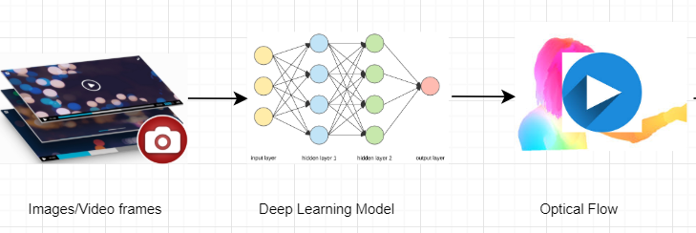

# REFERENCES

[1] Ilg, E., Mayer, N., Saikia, T., Keuper, M., Dosovitskiy, A., & Brox, T. (2017). Flownet 2.0: Evolution of optical flow estimation with deep networks. In Proceedings of the IEEE conference on computer vision and pattern recognition (pp. 2462-2470).

[2] Dosovitskiy, A., Fischer, P., Ilg, E., Hausser, P., Hazirbas, C., Golkov, V., ... & Brox, T. (2015). Flownet: Learning optical flow with convolutional networks. In Proceedings of the IEEE international conference on computer vision (pp. 2758-2766).

[3] Sun, D., Yang, X., Liu, M. Y., & Kautz, J. (2018). PWC-Net: CNNs for optical flow using pyramid, warping, and cost volume. In Proceedings of the IEEE Conference on ComputerVision and Pattern Recognition (pp. 8934-8943).

[4] Menze, M., & Geiger, A. (2015). Object scene flow for autonomous vehicles. In Proceedings of the IEEE

[5] Conference on Computer Vision and Pattern Recognition (pp. 3061-3070).

[6] B.D. Lucas, T. Kanade, ”An Image Registration Technique with an Application to Stereo Vision”, in Proceedings of Image Understanding Workshop, 1981, pp. 121-130

[7] Gituma, Mark. “What Is Optical Flow and Why Does It Matter in Deep Learning.” Medium, The Startup, 23 June 2019, https://medium.com/swlh/what-is-optical-flow-and-why-does-it-matter-in-deep-learning-b3278bb205b5

[8] <https://nanonets.com/blog/optical-flow/>

[9] Burton, Andrew; Radford, John (1978). Thinking in Perspective: Critical Essays in the Study of Thought Processes. Routledge. ISBN 978-0-416-85840-2.

[10] Horn, Berthold K.P.; Schunck, Brian G. (August 1981). "Determining optical flow" (PDF). Artificial Intelligence. 17 (1–3): 185–203. doi:10.1016/0004-3702(81)90024-2. hdl:1721.1/6337

[11] Gituma, Mark. “What Is Optical Flow and Why Does It Matter in Deep Learning.” Medium, The Startup, 23 June 2019, medium.com/swlh/what-is-optical-flow-and-why-does-it-matter-in-deep-learning-b3278bb205b5.

[12] G. Johansson, “Visual Perception of Biological Motion and a Model For Its Analysis", Perception and Psychophysics 14, 201-211, 1973

[13] Joonsoo Lee Al Bovik, 2009, The Essential Guide to Video Processing (Second Edition), CHAPTER 19 - Video Surveillance, https://doi.org/10.1016/B978-0-12-374456-2.00022-0